TASK 1:
#include <iostream>
using namespace std;

void minWalaHeap(int arr[], int n, int i) {
int smallest = i;
int left = 2 * i + 1;
int right = 2 * i + 2;

if (left < n && arr[left] < arr[smallest])
smallest = left;

if (right < n && arr[right] < arr[smallest])
smallest = right;

if (smallest != i) {
swap(arr[i], arr[smallest]);
minWalaHeap(arr, n, smallest);
}
}

void buildMinHeap(int arr[], int n) {
for (int i = n / 2 - 1; i >= 0; i--) {
minWalaHeap(arr, n, i);
}
}

void maxWalaHeap(int arr[], int n, int i) {
int largest = i;
int left = 2 * i + 1;
int right = 2 * i + 2;

if (left < n && arr[left] > arr[largest])
largest = left;

if (right < n && arr[right] > arr[largest])
largest = right;

if (largest != i) {
swap(arr[i], arr[largest]);
maxWalaHeap(arr, n, largest);
}
}

void buildMaxHeap(int arr[], int n) {
for (int i = n / 2 - 1; i >= 0; i--) {
maxWalaHeap(arr, n, i);
}
}

int main() {
int arr[] = {7, 1, 6, 2, 5, 9, 10, 2};
int n = sizeof(arr) / sizeof(arr[0]);

buildMinHeap(arr, n);

cout << "Min Heap: ";
for (int i = 0; i < n; i++) {
cout << arr[i] << " ";
}

cout << endl;

buildMaxHeap(arr, n);

cout << "Max Heap: ";
for (int i = 0; i < n; i++) {
cout << arr[i] << " ";
}

cout << endl;

return 0;
}

OUTPUT:
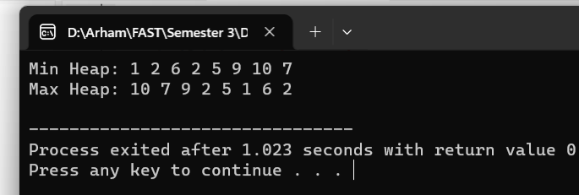

TASK 2:
#include <iostream>
using namespace std;

void minHeapify(int arr[], int n, int i) {
int smallest = i;
int left = 2 * i + 1;
int right = 2 * i + 2;

if (left < n && arr[left] < arr[smallest])
smallest = left;

if (right < n && arr[right] < arr[smallest])
smallest = right;

if (smallest != i) {
swap(arr[i], arr[smallest]);
minHeapify(arr, n, smallest);
}
}

void buildMinHeap(int arr[], int n) {
for (int i = n / 2 - 1; i >= 0; i--) {
minHeapify(arr, n, i);
}
}

void maxHeapify(int arr[], int n, int i) {
int largest = i;
int left = 2 * i + 1;
int right = 2 * i + 2;

if (left < n && arr[left] > arr[largest])
largest = left;

if (right < n && arr[right] > arr[largest])
largest = right;

if (largest != i) {
swap(arr[i], arr[largest]);
maxHeapify(arr, n, largest);
}
}

void buildMaxHeap(int arr[], int n) {
for (int i = n / 2 - 1; i >= 0; i--) {
maxHeapify(arr, n, i);
}
}

void heapSortAlgo(int arr[], int n) {
buildMaxHeap(arr, n);

for (int i = n - 1; i > 0; i--) {
swap(arr[0], arr[i]);
maxHeapify(arr, i, 0);
}
}

int main() {
int arr[] = {35, 33, 42, 10, 14, 19, 27, 44, 26, 31};
int n = sizeof(arr) / sizeof(arr[0]);

buildMinHeap(arr, n);

cout << "Min Heap: "<<endl;
for (int i = 0; i < n; i++) {
cout << arr[i] << " ";
}
cout << endl;

// Deleting the root node (minimum element in the minimum heap)
int root = arr[0];
arr[0] = arr[n - 1];
n--;
cout<<"root node Deleted"<<endl;
cout<<endl;

// Rebalancing the tree into a maximum heap
buildMaxHeap(arr, n);

cout << "Rebalanced Max Heap: "<<endl;
for (int i = 0; i < n; i++) {
cout << arr[i] << " ";
}
cout << endl;
cout<<endl;

heapSortAlgo(arr, n);
cout << "Sorted Output using Heap Sort: "<<endl;
for (int i = 0; i < n; i++) {
cout << arr[i] << " ";
}
cout << endl;

return 0;
}

OUTPUT:
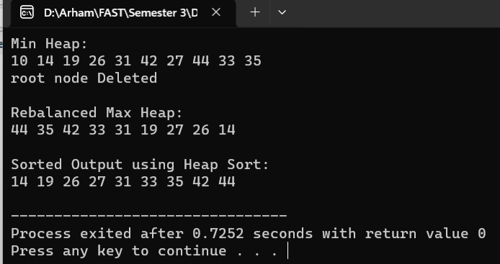

TASK 3:
#include <iostream>
#include <cstdlib>
using namespace std;

class Task {
public:
int priority;
int taskID;
};

class taskNode {
public:
Task task;
taskNode* left;
taskNode* right;

taskNode(Task task) {
this->task = task;
this->left = NULL;
this->right = NULL;
}
};

taskNode* insert(taskNode* root, Task task) {
if (root == NULL) {
taskNode* newNode = new taskNode(task);
return newNode;
}

if(task.priority > root->task.priority) {
root->left = insert(root->left, task);
}
else{
root->right = insert(root->right, task);
}
return root;
}

void deleteNodes(taskNode* root) {
if (root == NULL){
return;
}

deleteNodes(root->left);
cout << "Deleting Task " << root->task.taskID << " with Priority " << root->task.priority << endl;
deleteNodes(root->right);
delete root;
}

void printTree(taskNode* root) {
if (root == NULL) {
return;
}

//TO GET TO THE LEFT MOST NODE AS IT WILL HAVE THE GREATEST PRIORITY while Inserting
printTree(root->left);
cout << "Task " << root->task.taskID << " with Priority " << root->task.priority << endl;
printTree(root->right);
}

int main() {
int tasksAmnt;
taskNode* root = NULL;

cout << "Input tasks: ";
cin >> tasksAmnt;

for (int i = 0; i < tasksAmnt; i++) {
Task task;
cout << "Enter the ID for task " << i + 1 << ": ";
cin >> task.taskID;
task.priority = rand() % 10;
root = insert(root, task);
}

cout << "The initial tree is:" << endl;
printTree(root);
cout<<endl;

cout << "The tree is being deleted according to descending priority:" << endl;
deleteNodes(root);

return 0;
}

OUTPUT:
